DeShawn McKinley
CS 255
Professor McHann
26 April 2026

CS 255 System Design Document

UML Diagrams

UML Use Case Diagram

DriverPass System

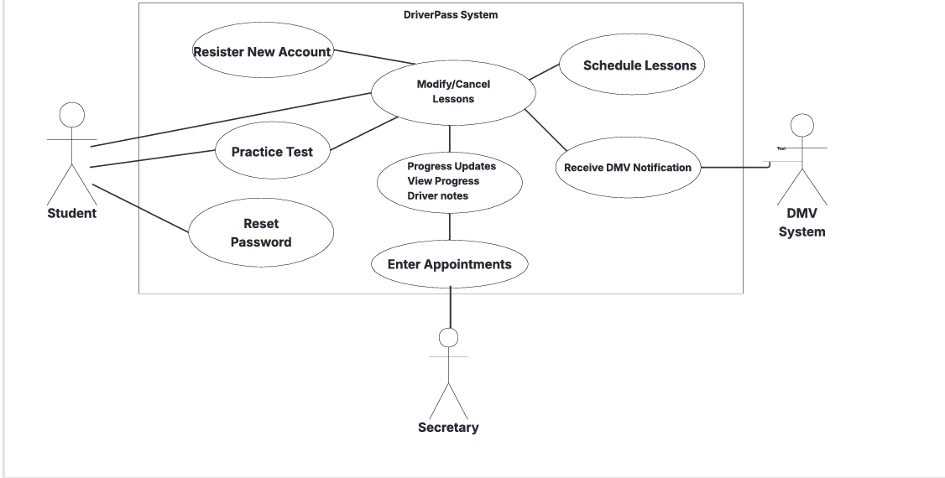

UML Activity Diagrams

Register New Student Activity Diagram
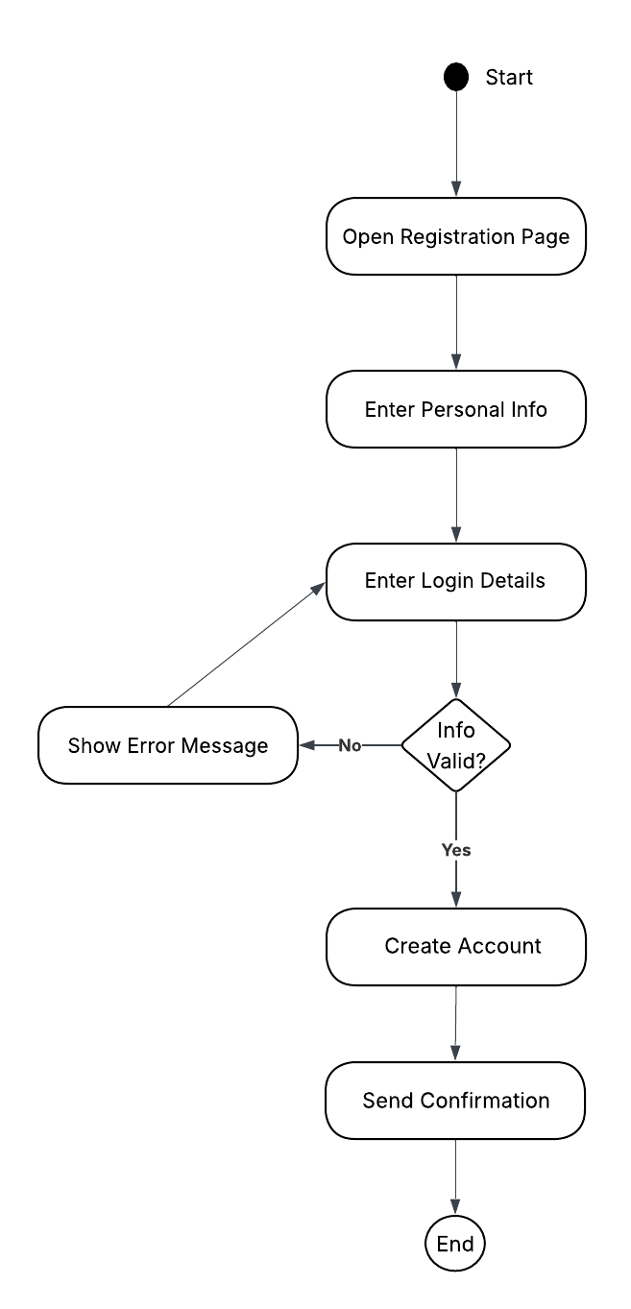

Schedule Driving Lessons Activity Diagram
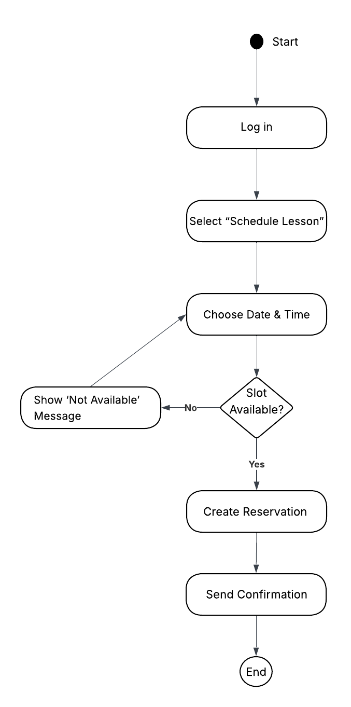

UML Sequence Diagram
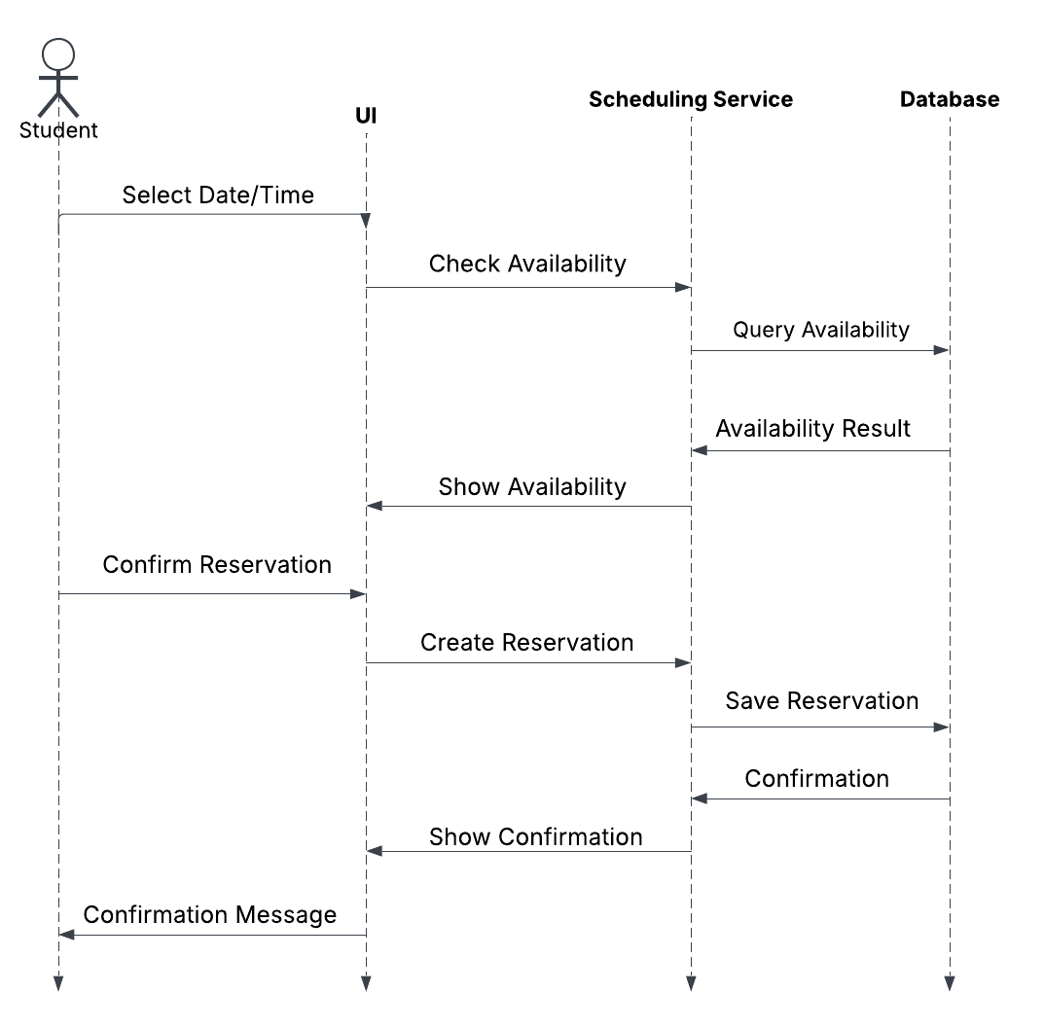

UML Class Diagram

DriverPass System UML Class Diagram
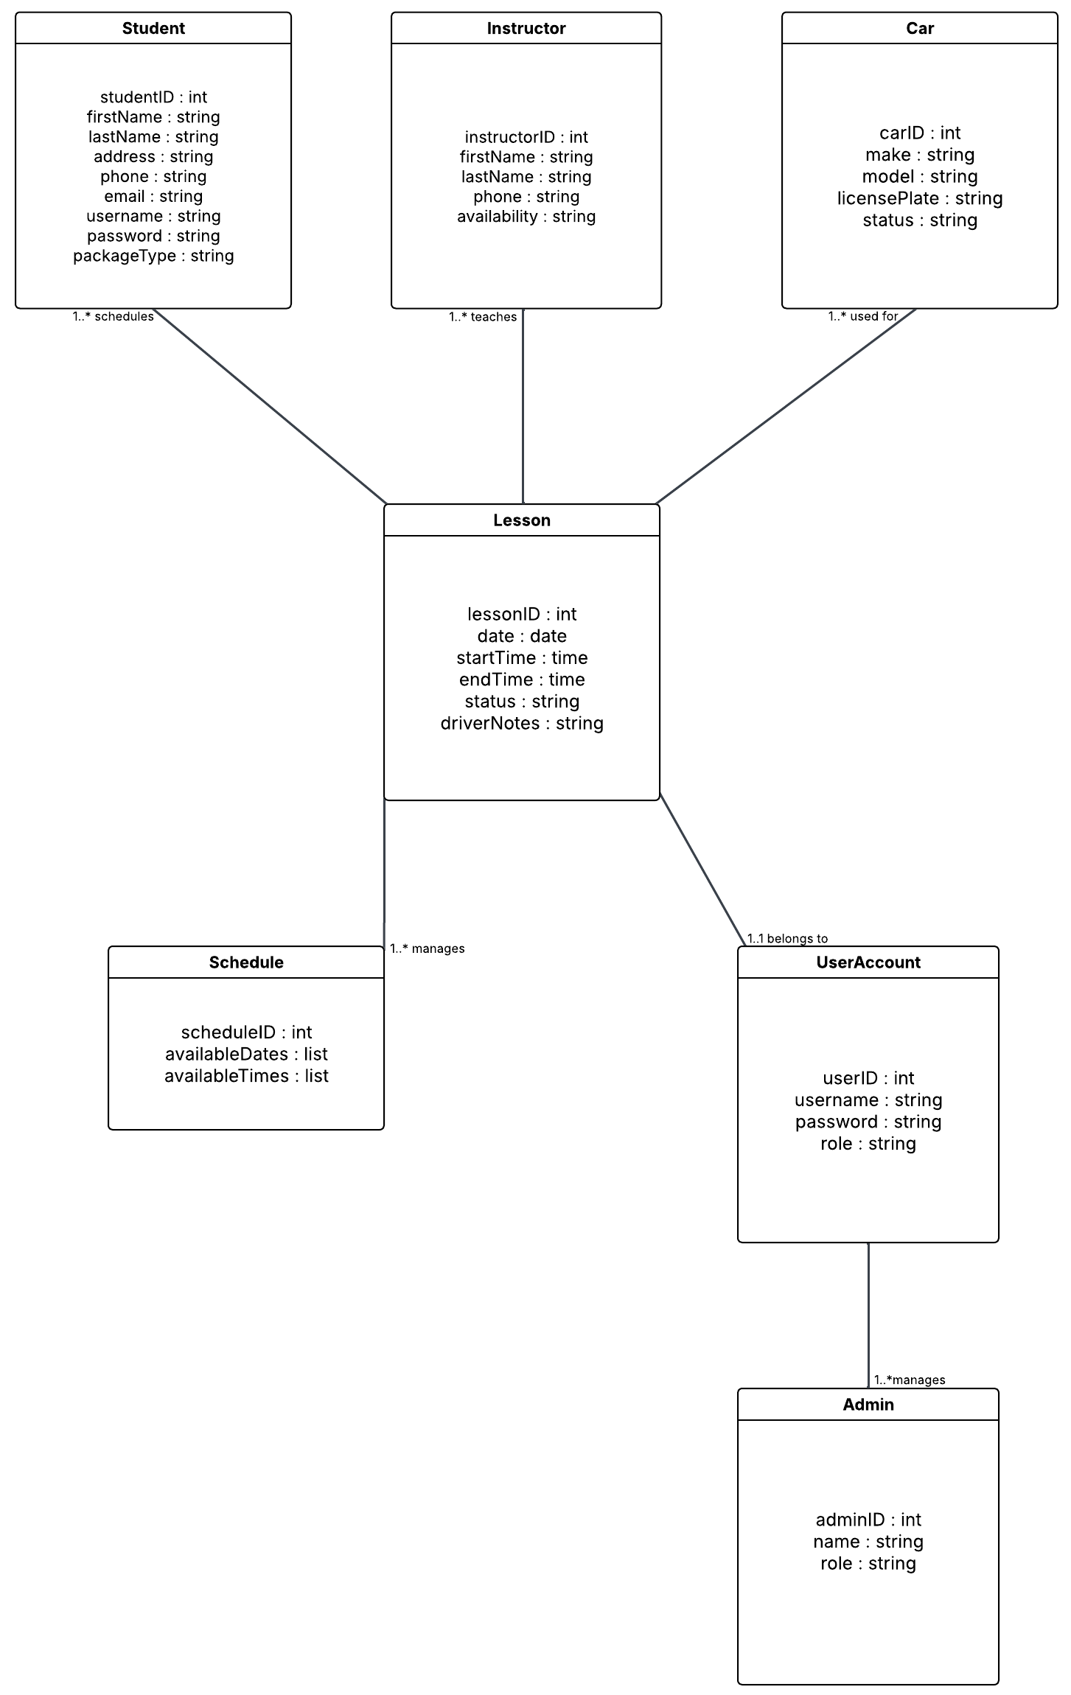

Technical Requirements
The DriverPass system requires a cloud-based technical setup that supports online scheduling, practice tests, account management, and DMV updates. Since the client wants users to access the system from any device, the entire application must run through a modern web browser without requiring anything to be installed locally.
Hardware
- Users need a computer, tablet, or smartphone with internet access.
- The system will run on cloud for hosting and storage
- Cloud hosting must support automatic backups, storage for lesson data, and scalable processing power.
Software
- The system needs a reliable web server to host the application and handle incoming requests.
- A backend framework like Node.js, Java, or Python is required to run the core logic of the system.
- A cloud-based database is needed to store user accounts, scheduling lessons, instructor details, and activity logs.
- End users will access the system through any modern web browser like Chrome, Edge, Safari, or Firefox.
Tools
- The development team will use a code editor like Visual Studio Code or another IDE they prefer.
- UML and design tools like Lucidchart for modeling.
- Git will be used for version control so the team can track changes and collaborate easier.
- Testing tools like Postman or Selenium will help verify that the system’s features functions correctly.
Infrastructure
- The system will be hosted on a cloud platform like AWS, Azure, or Google Cloud to ensure reliability and automatic backups.
- A secure API connection is needed so the system can receive DMV updates.
- Notifications like confirmations and password resets will be handled through email or text messaging services.
- The system must support different user roles, including students, instructors, the secretary, and admin staff.

Security
- All communication between users and the system must be encrypted using HTTPS/TLS.
- Passwords must be stored securely using hashing and proper authentication methods.
- Accounts should temporarily lock after several failed login attempts to prevent unauthorized access
- The system must keep detailed logs showing who created, changed, or canceled lessons.

